5.Write a Pandas program to create a bar plot of the trading volume of Alphabet Inc.
stock between two specific dates.

Code:
import pandas as pd
import matplotlib.pyplot as plt
stock = pd.read_csv("alphabet_stock_data.csv")
stock["Date"] = pd.to_datetime(stock["Date"])
data = stock[(stock["Date"] >= "2016-10-03") &
(stock["Date"] <= "2016-10-07")]

plt.figure(figsize=(8,5))
plt.bar(data["Date"].dt.strftime("%Y-%m-%d"), data["Volume"])
plt.title("Alphabet Inc. Trading Volume")
plt.xlabel("Date")
plt.ylabel("Volume")
plt.show()

Output: 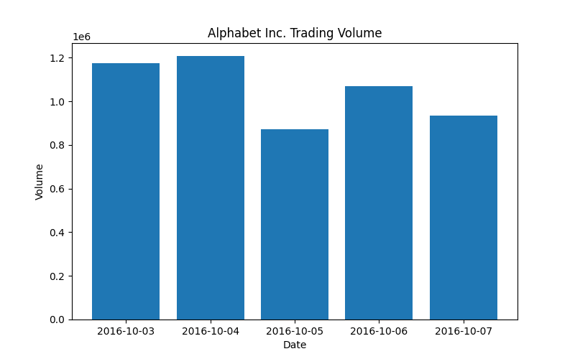
6.Write a Pandas program to create a scatter plot of the trading volume/stock prices of
Alphabet Inc. stock between two specific dates.

Code:
import pandas as pd
import matplotlib.pyplot as plt

stock = pd.read_csv("alphabet_stock_data.csv")

stock["Date"] = pd.to_datetime(stock["Date"])

data = stock[(stock["Date"] >= "2016-10-03") &
(stock["Date"] <= "2016-10-07")]

plt.figure(figsize=(8,5))
plt.scatter(data["Close"], data["Volume"])
plt.title("Trading Volume vs Closing Price")
plt.xlabel("Closing Price")
plt.ylabel("Trading Volume")
plt.grid(True)
plt.show()

Output:
